Monday, November 29, 2021

Hello boys and girls,
Happy Monday! I hope that you all had a nice weekend! Were you excited to see the snow? It is pretty with the Christmas lights on! I think we will get more snow today too! You should try and get outside and play! Fresh air and exercise are super good for us!
Have a great day and I hope to see you soon!

- Logon to Dreambox and play for 20 minutes.
- We have been learning about odd and even. Count the objects in each of these groups and figure out if it is odd or even.

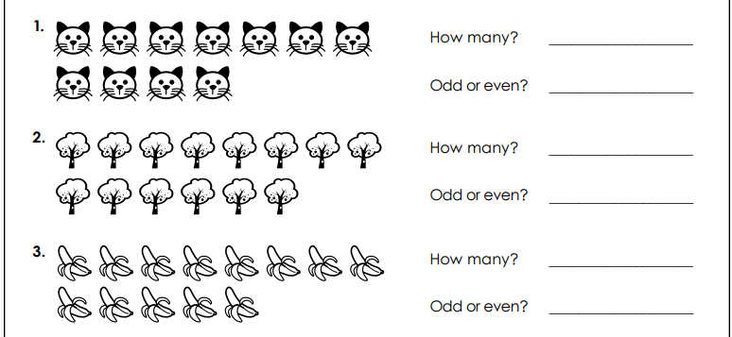

- Play “Coconut Odd or Even”: https://www.topmarks.co.uk/learning-to-count/coconut-odd-or-even

