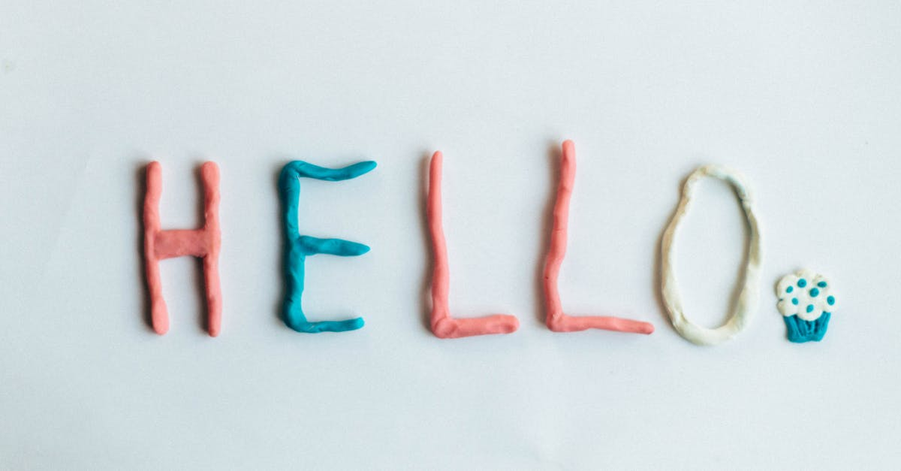

Welcome to My Teacher Page!
It is my hope that this will be a convenient and efficient means of
Communication between our classroom and your home.

I will try to post our week at a glance and special news to keep you up to date.
Thanks for taking time to stop by, and please continue to do so.
Regards, Mrs. J. Craig

