

January 11, 2022
Grade Two Math

Happy Tuesday boys and girls!!

I hope that you all had a wonderful holiday season with your families! I can’t believe it is 2022! Please check back here daily for activities and links and more directions on what to do with your learning packages!

- Use the picture below. Figure out how many items you can buy with your $10. The teddy bears are $1, and the coats are $2. You can buy all of one item or a mixture of both. Find at least two different ways to spend your $10.

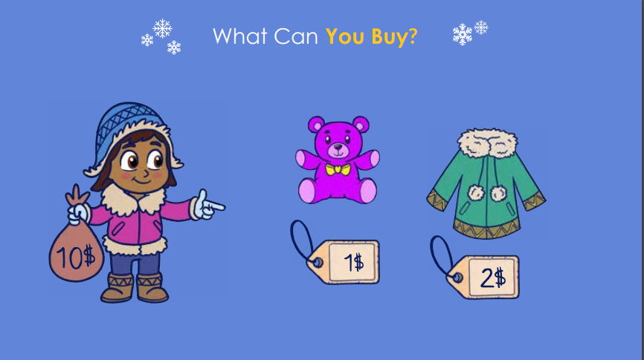
- Play Dreambox for 20 minutes.
- Complete the “Ball Drop Subtraction” sheet and begin the color by code “Happy New Year” sheet.

Have a great day!
Love, Mrs. Newman

