January 11, 2022
Grade Three Math

Happy Tuesday boys and girls!!

I hope that you all had a wonderful holiday season with your families! I can’t believe it is 2022! Please check back here daily for activities and links and more directions on what to do with your learning packages!

- Use the picture below. Figure out how many items you can buy with your $10. The robots are $1, the scarves are $2, and the sleds are 25 cents. You can buy all of one item or a mixture of all three. Find at least two different ways to spend your $10.

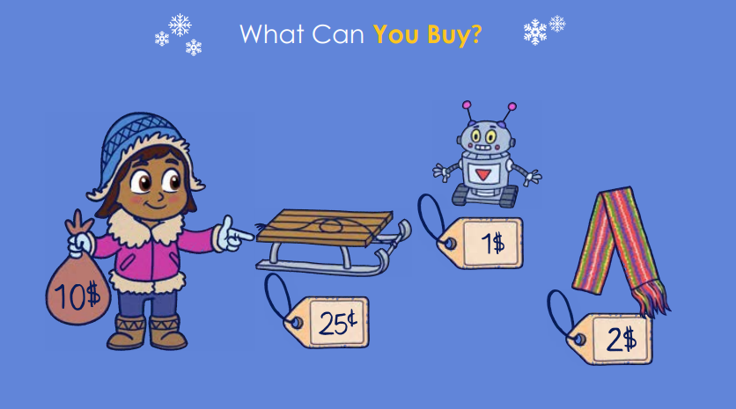
- Play Dreambox for 20-25 minutes.
- Complete one of the activities from the learning package you have at home. The game “Racing for Raindrops” will help you practice both your addition and subtraction facts! Too bad we couldn’t change the raindrops into snowflakes!

Have a great day!
Love, Mrs. Newman

