

January 12, 2022
Grade Three Math

Happy Wednesday boys and girls!!

It sure was a cold day yesterday! Hope you stayed warm and cozy. It might be better today so hopefully you can get outside for some fresh air and exercise! Please check back here daily for activities and links and more directions on what to do with your learning packages!

I would love to see any of the work you do! If possible, have a parent email a picture of what you have done!

- Play Splash Learn (Math) for 20 - 25 minutes. Try the assigned tasks in the “From My Teacher” section first!

- Complete one of the activities from the learning package you have at home. If you haven’t played the game “Lots of Spots” yet it will help you practice your two-digit addition!

- Read the “Detectives Wanted” poster below. Try and solve at least 3 of the clues. Of course, you may do all of them!!
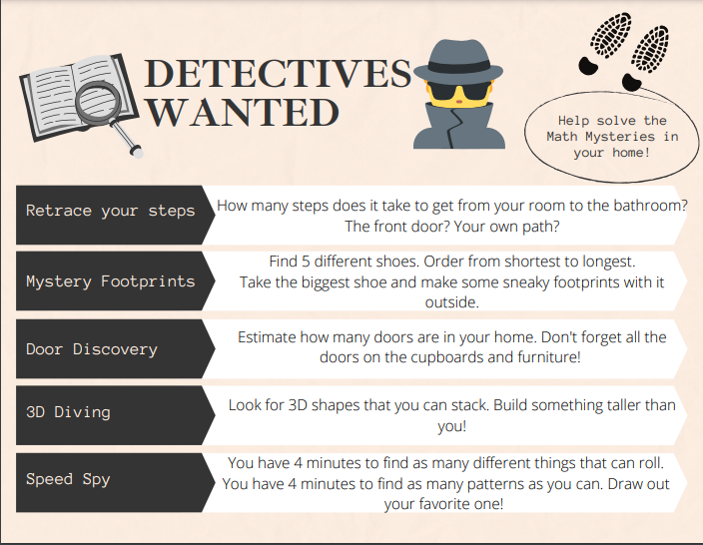

Have a great day!

Love, Mrs. Newman

