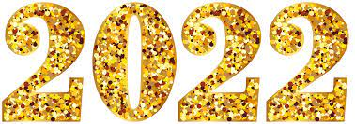
January 12, 2022
Grade One Literacy

Happy Wednesday boys and girls!!
Wow, it sure was cold yesterday! Hope you stayed warm and cozy! Today might be a bit better so you can get outside for some fresh air and exercise! Please check back here daily for activities and links and more directions on what to do with your learning packages!

- Check out the January calendar on starfall: https://www.starfall.com/h/holiday/calendar/?t=346671025
- Enjoy your poem “New Year Chant” again!

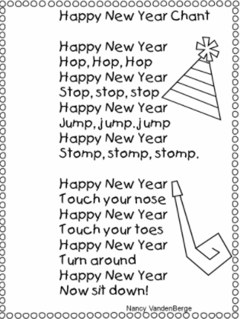
- Reading: Read to Self or Read to Someone one of the books from your learning package.

- Writing: Watch and listen to the story book “Squirrel’s New Year’s Resolution” and complete the writing sheet that goes with it. You draw a picture and write about your favorite part of the story. Did you like when Squirrel helped Mole and Turtle? Or maybe you liked the joke that Squirrel told Porcupine. You might like something different too.
Remember to a) use a capital letter at the beginning of each sentence b) put a space between each word c) put punctuation at the end of each sentence and d) read over your sentence so you know it makes sense.

Link to story:
https://www.youtube.com/watch?v=EAMDa-udC_I

If possible. you could have a parent take a picture of your writing and email it to me. I would love to know what part you liked best!

I hope you all have a wonderful day!

Love, Mrs. Newman

