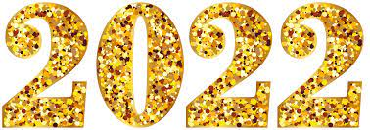

January 13, 2022
Grade One Literacy

Happy Thursday boys and girls!!

Please check back here daily for activities and links and more directions on what to do with your learning packages!

- Check out the January calendar on starfall: https://www.starfall.com/h/holiday/calendar/?t=346671025
- Enjoy your poem “New Year Chant” again!

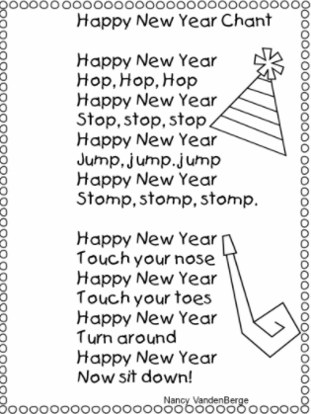
- Reading: Read to Self or Read to Someone one of the books from your learning package.

- Writing: If you haven’t yet completed your “Holiday Snapshots” or “Squirrel’s New Year’s Resolution” writing you can work on that today. If you are ready to move on, the next sheet gives you four winter items (earmuffs, scarf, gloves, and ice skates). You can draw a picture and write a couple sentences about how you could use those items. Or make up your own story, using those items. Remember to a) use a capital letter at the beginning of each sentence b) put a space between each word c) put punctuation at the end of each sentence and d) read over your sentence so you know it makes sense.

- Here is a link to a fun video to get you moving and grooving through all this cold weather! It is called “Brrrrrrrrrrrr”

https://www.youtube.com/watch?v=yjd7Z_7DdU4

Have a wonderful day!

Love, Mrs. Newman

