

January 13, 2022
Grade Two Math
Happy Thursday boys and girls,

Please check back here daily for activities and links and more directions on what to do with your learning packages!

- Play 20 minutes on Dreambox. Remember to try and not pause an activity. It is better for you to just try your best and finish the activity before moving on to another one.

- If you have completed the “Ball Drop Subtraction” sheet and the color by code “Happy New Year” sheet you can choose one of the other activities in your learning pack to complete. The “Build the Snowmen” game is a fun option, and it helps you practice both your addition and subtraction facts.

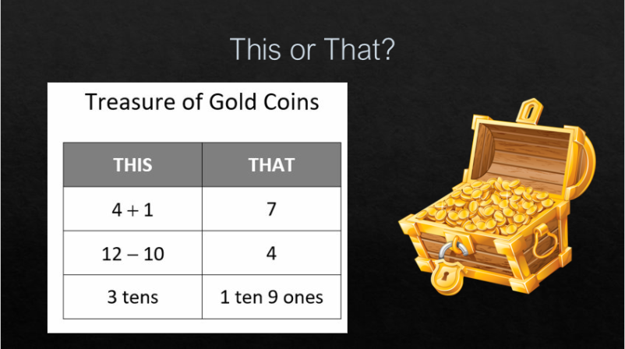

For each row, decide how many gold coins you would want. this or that. For example, the first row: would you want 4+1 gold coins OR 7 gold coins?

