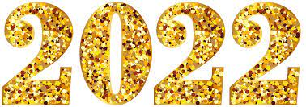

January 14, 2022
Grade One Literacy

Happy Friday boys and girls!!

Please check back here daily for activities and links and more directions on what to do with your learning packages!

- Check out the January calendar on Starfall: https://www.starfall.com/h/holiday/calendar/?t=346671025
- Enjoy your poem “New Year Chant” again!

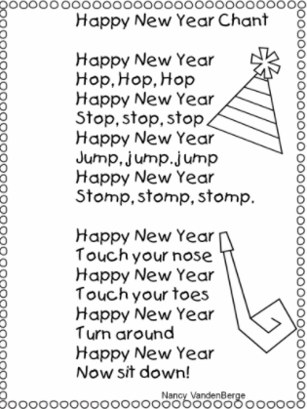
- Reading: Read to Self or Read to Someone one of the books from your learning package.

- Writing: If you are still working on holiday snapshots, Squirrel’s New Year’s Resolution or the four winter items sheet, continue with those. If you are all caught up, you can complete the sheet “What is your favorite part of the winter season? Why?” Do you like an outdoor winter activity like sliding or building snowmen? Or maybe you like playing hockey or skating. If it’s possible, have someone email a picture of your writing when you are done. I would love to know what your favorite part of winter is!!

Have a wonderful weekend!! Check back on Monday!!

Love, Mrs. Newman

