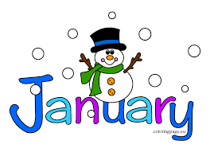
January 17, 2022
Grade 1 Literacy
Happy Monday everyone,
I hope that you all had a wonderful weekend and got outside to enjoy the snow! Please check back here daily for activities and links and more directions on what to do with your learning packages!

- Check out the January calendar on Starfall: https://www.starfall.com/h/holiday/calendar/?t=346671025
- Here is our new fun poem for the week. Enjoy reading it each day, it’s a good one!
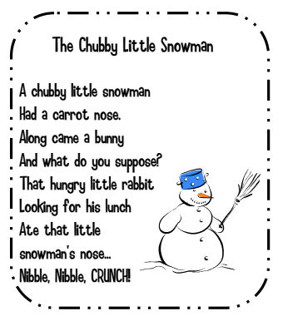
- Reading: Read to Self or Read to Someone one of the books from your learning package.

- Writing: Work on/complete the writing activities from last week (holiday snapshots, Squirrel’s New Year’s Resolution, 4 winter items sheet #1, favorite part of winter). When ready, begin the 4 winter items sheet #2 with the snowman, scarf, gloves, and hat. Write about a time you may have used those objects or make up a story with them.

- Click the link for a fun winter brain break called “Winter Chase/Winter Run”!! Enjoy

https://www.youtube.com/watch?v=YZ_XX_VEmj4

Have a great day!
Love, Mrs. Newman

