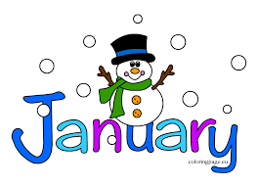
January 18, 2022
Grade 1 Literacy
Happy Tuesday everyone,
More snow means more outdoor fun! Enjoy sliding or building a snowman or whatever you like to do in the snow! Please check back here daily for activities and links and more directions on what to do with your learning packages!
- Check out the January calendar on Starfall: https://www.starfall.com/h/holiday/calendar/?t=346671025
- Here is our new fun poem for the week. Enjoy reading it each day, it’s a good one!
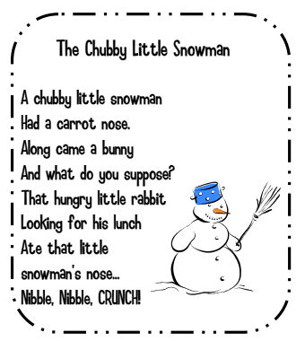
- Reading: Read to Self or Read to Someone one of the books from your learning package.

- Writing: Listen to the story “Snowmen at Night” (link below) and complete the writing sheet that goes with it. If you could tell a snowman what to do at night, what would it be?
https://www.youtube.com/watch?v=kacbEj4pwgo

Have a great day!
Love, Mrs. Newman

