January 18, 2022
Grade 3 Math
Happy Tuesday everyone,
More snow means more outdoor fun! I hope you can get outside to slide or make a snowman or whatever else you like to do! Please check back here daily for activities and links and more directions on what to do with your learning packages!

- Use the January 2022 calendar to answer the following questions. Record your answers and bring them back to school when we return.
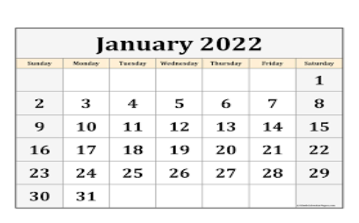
1. How many days in January?
2. How many days until the end of January?
3. Which month comes after January?
4. How many Mondays in January?
5. How many Fridays?
6. Ann is leaving to visit her grandmother on January 18. She will be gone 10 days. What is the day and date she will return? Will she be gone more or less than one week?

- Play Dreambox for 20-25 minutes.
- Complete one of the assignments from your learning package.

Have a great day! I sure do miss you all
Love, Mrs. Newman

