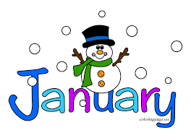
January 19, 2022
Grade 1 Literacy
Happy Wednesday everyone,
It sure is a chilly morning out there! Hope you stay warm and cozy and can get outside when it warms up! Please check back here daily for activities and links and more directions on what to do with your learning packages!
- Check out the January calendar on Starfall: https://www.starfall.com/h/holiday/calendar/?t=346671025
- Here is our new fun poem for the week. Enjoy reading it each day, it’s a good one!
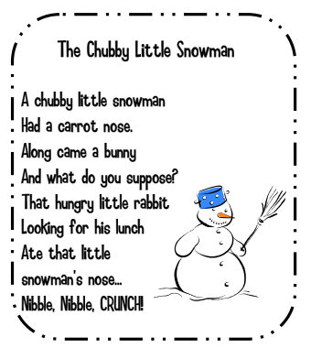

- Reading: Read to Self or Read to Someone one of the books from your learning package.

- Writing: If you have completed all the writing pieces so far you can move on to the third winter objects sheet (snow, snowballs, sledding and build a snowman). Use all or some of these words in a few sentences. Remember to use capital letters at the beginning of sentences, punctuation at the end of sentences, spaces between your words and read it over so it makes sense.

If you aren’t ready for this sheet yet go back and keep working on your other assignments.

Have a great day!
Love, Mrs. Newman

