January 19, 2022
Grade 3 Math

Happy Wednesday everyone,
It sure is a chilly morning out there! Hope you stay warm and cozy and can get outside when it warms up! Please check back here daily for activities and links and more directions on what to do with your learning packages!

- Please play Splash Learn for 20-25 minutes today.

- Complete one of the assignments or games from your home learning package. You can always replay one of the games you have at home from this package or an earlier one.

- Complete the Which One Doesn’t Belong (snowman) activity below.

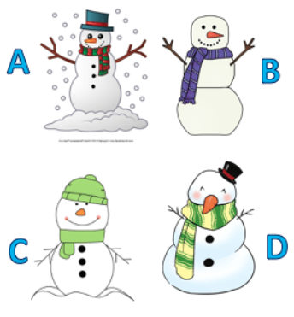

Think about these questions:
What do you notice?
What makes all the items alike?
What makes them different?
Record your thoughts for these questions:
Which one doesn’t belong?
Can you share your reasoning to justify your answer?

