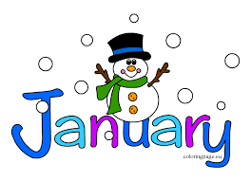
January 20, 2022
Grade 1 Literacy
Happy Thursday everyone,
I hope you are all doing well! I sure do miss you!! Please check back here daily for activities and links and more directions on what to do with your learning packages!
- Check out the January calendar on Starfall: https://www.starfall.com/h/holiday/calendar/?t=346671025
- Here is our new fun poem for the week. Enjoy reading it each day, it’s a good one!
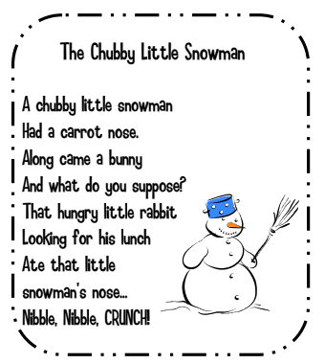

- Reading: Read to Self or Read to Someone one of the books from your learning package.

Writing: If you have completed all the writing pieces so far you can click on the link below and watch the story “Snowman Magic”. The writing sheet that goes with it asks you what you would do if a magical snowman gave you a wish. Remember to use capital letters at the beginning of sentences, punctuation at the end of sentences, spaces between your words and read it over so it makes sense.

If you aren’t ready for this sheet yet go back and keep working on your other assignments.

https://www.youtube.com/watch?v=6uPOQ8RELvg

Have a great day!
Love, Mrs. Newman

