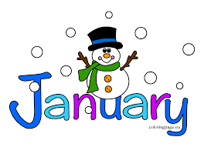
January 21, 2022
Grade 1 Literacy
Happy Friday everyone,
I hope that you all have an awesome weekend! Please check back here daily for activities and links and more directions on what to do with your learning packages!
- Check out the January calendar on Starfall: https://www.starfall.com/h/holiday/calendar/?t=346671025
- Here is our new fun poem for the week. Enjoy reading it each day, it’s a good one!
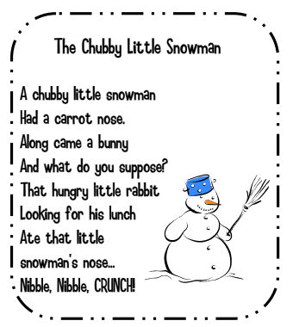

- Reading: Read to Self or Read to Someone one of the books from your learning package.

- Writing: If you are ready for the last writing sheet in your package you can click the link below to watch “Snowmen at Work” (even if you aren’t ready for this sheet you can still watch it )The sheet asks you to dress your snowman as if he or she is going to work and then explain what they will be and what they will do. Remember to use capital letters at the beginning of sentences, punctuation at the end of sentences, spaces between your words and read it over so it makes sense.

If you aren’t ready for this sheet yet go back and keep working on your other assignments.

https://www.youtube.com/watch?v=KlG7fiNakxE

Have a great day!
Love, Mrs. Newman

