January 21, 2022
Grade 2 Math

Happy Friday everyone,
I hope you all have an awesome weekend! Please check back here daily for activities and links and more directions on what to do with your learning packages!

- Please play Dreambox or Splash Learn for 20 minutes today.

- Complete one of the assignments or games from your home learning package. You can always replay one of the games you have at home from this package or an earlier one.

- Friday Fun: Figure out what my mystery number is. I will reveal the answer on Monday

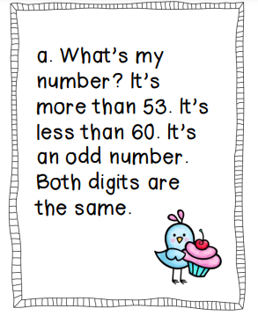

Have a great day!
Love, Mrs. Newman

