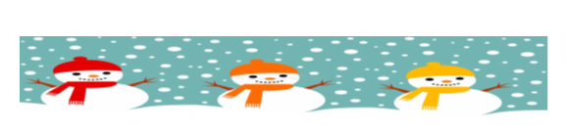
January 25, 2022
Grade 1 Literacy
Happy Tuesday everyone,
Please check back here daily for activities and links and more directions on what to do with your learning packages!
- Check out the January calendar on Starfall: https://www.starfall.com/h/holiday/calendar/?t=346671025
- Here is our new poem for the week! It is one of my favorites! You will laugh everyday you read it this week!
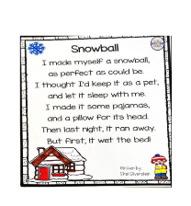

- Reading: Read to Self or Read to Someone one of the books from your learning package.
- Writing: In your new package you will find three writing sheets and three word work sheets. Each writing sheet goes along with a story that is linked below and the word work sheets cover the topics of rhyming and initial and ending sounds. You can have your child choose each day what sheet they would like to do. They don’t have to be done in any specific order.

How to Catch a Snowman
https://www.youtube.com/watch?v=w1T4S1z0Iu0
Writing ideas:
What was your favorite trap?
How would you try and catch a snowman?

The Snowy Day
https://www.youtube.com/watch?v=FmZCQfeWjeQ
Writing ideas:
What do you like to do on a snowy day?
What was your favorite part?

A Loud Winter’s Nap
https://www.youtube.com/watch?v=YRXoZjmk5LM
Writing ideas:
Would you like to sleep all winter? Why or why not?
What was your favorite part?

Have a great day! Love, Mrs. Newman

