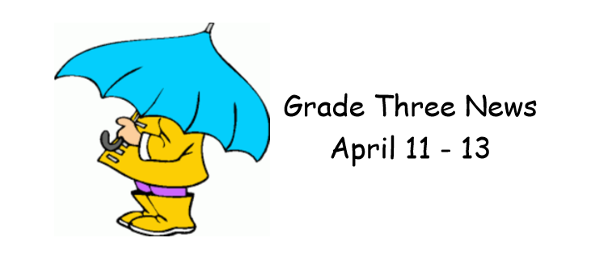

We had an extra short week due to the Easter Monday holiday and Parent Teacher/Professional Learning on Friday!
It was an exciting few days in Math as we began learning about multiplication! Our focus at the moment is on the 2 times table. We are relating it to our addition double facts, and everyone is enjoying the games and activities!
In literacy we are continuing to learn strategies to help with our reading comprehension activities! We have also been practicing writing friendly letters!
We continue to work on our informational reports on a New Brunswick animal. Students are doing a great job learning how to research and put their information together!
This week in Personal Wellness we began learning about where our food comes from! This will continue next week as well!

