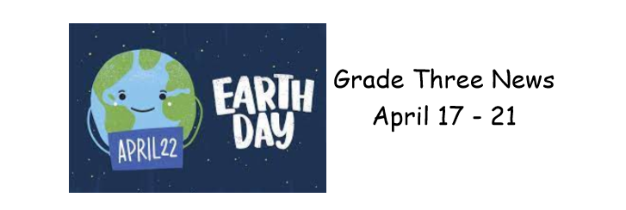

We had a wonderful week welcoming Spring weather to Napan Elementary!
In Literacy, we continued writing our animal informational reports! You are going to be very impressed when you read the amazing work your child did!
In Math, we continued working on our 2 times table! It’s awesome how much everyone is picking up these facts and enjoying the games and activities.
We learned about food sources and where the items in our lunch boxes come from. There were fun activities using food cards to decide what ingredients they are made from!
Earth Day was a major theme of the week and will continue to be next week! We attended a virtual session today where we were presented with ideas on how we can help protect our Earth! Stay tuned as we will be participating in an Earth Day Bingo!
Happy Weekend Everyone!

