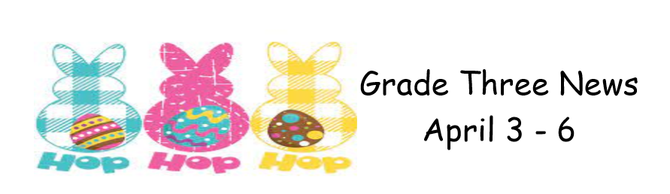

Our four-day week will center around all things Easter!
Our literacy block will focus on Easter word work, responding to literature and writing our own Easter stories!
In Math we will be illustrating, pictorially and concretely, the meaning of place value for numerals to 1000 and playing some Easter themed Math games to reinforce our mental math skills.

During the month of April, we will focus on Mango 5210 with each week dedicated to learning more about leading a healthy lifestyle. We will also be learning a dance to participate in the district dance challenge!

Reminder that report cards will go home on Thursday, April 6. Enjoy your 4-day Easter weekend with your awesome children!

