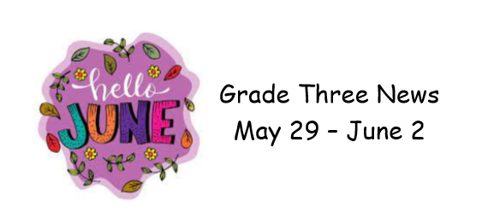
Wow, it is hard to believe that it is now June, and we are in our last few weeks of school!
In Literacy we are reviewing our reading comprehension strategies. This week we focused on summarizing and visualization. During writing workshop students are choosing topics they are interested in and writing a paragraph. Prompts are available to help develop ideas if needed.
In Math, we completed activities related to the 4 times table, while also reviewing the 0,1,2,5 and 10 tables. We will start reviewing previous outcomes, mainly addition and subtraction with 2- and 3-digit numbers.
During Cross Curricular we completed our science unit on plants and soil and started a health lesson on caring for our teeth.
We have a busy few weeks leading up to the last day of school so please check the school calendar and your child’s home folder for information.
Enjoy your weekend and try and stay dry

