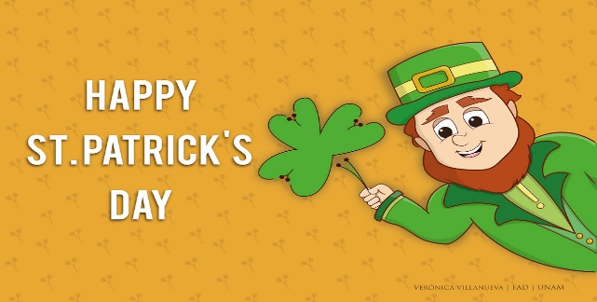
This Photo by Unknown Author is licensed under CC BY
A Peek At Our Week
March 13-17

We will be completing several St. Patrick’s Day activities in all subject areas as we go about our week.
This week we will be working on the following outcomes:
Word Work Focus
~short vowel sound review, final blends/diagraphs (-ck)
Writing Focus
~ Personal Narrative (self-reflection)
~Traits of Writing~ adding details and conventions (proper spacing, word wall words, and stretching unknown words and recording the sounds heard)
Math Focus
Grade 1~Solving addition number stories using hands on materials, drawing pictures and recording number sentences (ex. 5 + 6 = 11).
Grade 2~Showing the meaning of two-digit numerals to 100 using materials and with pictures. As well, we will be working on solving two-digit number sentences using a variety of hands-on materials.
Exploratory Focus
~St. Patrick's Day (history, leprechauns, idea of being lucky, rainbows, directed drawing)
* Remember we go skating on Thursday for one final time!

