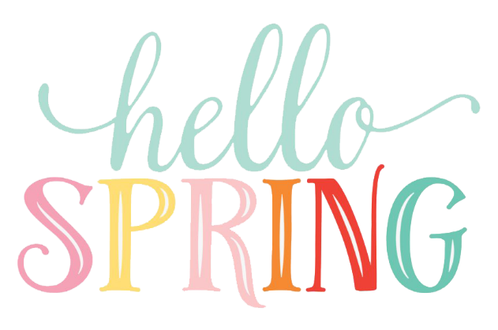
A Peek At Our Week
March 20th-24th

This week we will be working on the following outcomes:
Word Work Focus
~short vowel sound review, initial blends (spl, spr)
Writing Focus
~ Personal Narrative (small moment stories)
~Traits of Writing~ choosing a small moment story, adding details to expand idea, using some transitional words (first, next, then, after that, finally) and continuing to work on improving conventions (proper spacing, word wall words, and stretching unknown words and recording the sounds heard)
Math Focus
Grade 1~We will be continuing to work on solving addition number stories using hands on materials, drawing pictures, and recording number sentences (ex. 5 + 6 = 11).
Grade 2~Solving two-digit addition stories using a variety of hands-on materials
Exploratory Focus
~Spring (Seasonal Changes)
* Reminder there will be no school on Friday, March 24th as teachers will be writing report cards and participating in some Professional Development!

