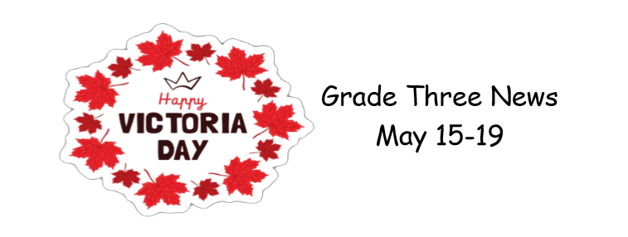
We had another fabulous week in Grade Three
During our literacy time we are working on writing a good paragraph. We start with a topic sentence, develop some supporting details, and then write the paragraph. We will continue with this next week as well.
In math we are continuing with our times tables, focusing this week on the 0 and 1 tables while always reviewing previously covered ones, 2, 5, and 10. Next week we will do the 4 times table and begin reviewing other outcomes we covered this year.
The highlight of our week was a virtual session we did Thursday. It focused on the story book “How to Code a Sandcastle” which taught us what coding is and, in simple terms, explained how to do it. There were three small problems presented and when the students completed them, they had created some awesome sandcastles! Check out the image gallery for some cool pictures!
Jump Rope for Heart went very well Friday afternoon! Many thanks to all our families for raising over $2000!! Remember to continue working on earning energy cubes!
Have a wonderful long weekend!! See you Tuesday

