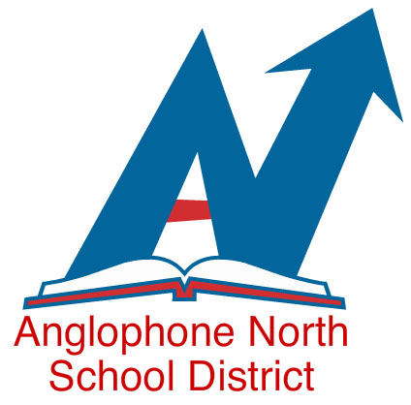

IMPORTANT NOTICE TO ALL GRADES K & 5 PARENTS / GUARDIANS
Information sessions regarding program selection for September 2019, will be held according to the following schedule.
The information will be provided on options for the Grades 1 and 6 students: English Prime Program, Early Gr. 1 French Immersion Program and the Late Gr. 6 French Immersion Program.
Parents who wish to enroll their children in the Grade 1 Entry or Grade 6 Entry French Immersion Programs will be required to complete the electronic registration form located on the ASD-North web site.

Area | Where | Date | Snow date
Bathurst area | Parkwood Heights Elementary School | January 10, 2019 @6 :30 | January 14, 2019 @6 :30
Upper Miramichi area | North and South Esk Elementary School | January 15, 2019 @6 :30 | January 16, 2019 @6 :30
Miramichi area | Gretna Green School | January 17, 2019 @6 :30 | January 21, 2019 @6 :30
Rexton area | Rexton Elementary School | January 22, 2019 @6 :30 | January 28, 2019 @6 :30
Campbellton /Dalhousie areas | L. E. Reinsborough School | January 29, 2019 @6 :30 | January 30, 2019 @6 :30

For additional information, contact your local school
or the French Second Language Coordinators :
Linda Dickson
Michelle Tobin - Forgrave

