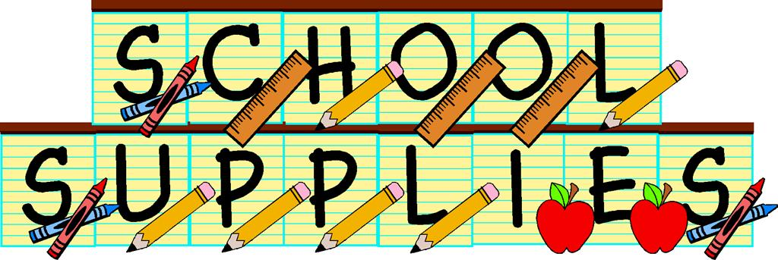Napan Elementary
Supplies for Grade 5
2019-2020

- HB Pencils – 3 pkgs (Please maintain a generous supply.)
- Erasers – 3 white (not pink) – Please maintain a generous supply.
- Scissors
- Glue – large glue stick
- 1 pkg dry erase markers
- 30 cm ruler
- A soft pencil case large enough to hold glue, scissors and pencils.
- Small pencil sharpener (keep in small baggie)
- $4 for Homework Binder
- Indoor sneakers
- 1 pkg pencil crayons
- 3 Duotangs
- 1 Pkg. Hilroy Notebooks
- 2 boxes of kleenex

