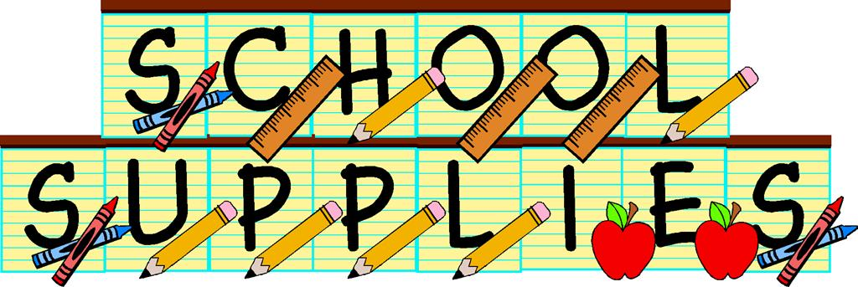

Napan Elementary
Supplies for Grade 3
2019-2020

- 2 white erasers
- 3 boxes of Kleenex
- Scissors
- 3 glue stick
- Soft pencil case large enough for pencil crayons, glue and scissors
- Small pencil sharpener
- Indoor sneakers (appropriate for phys. Ed)
- 8 dry erase markers–any colors (Expo)
- $4 to purchase a Homework Binder
- 1 box of small Ziplock bags

Our School Supply list is much shorter this year as we had a large donation of school supplies from some Businesses.

