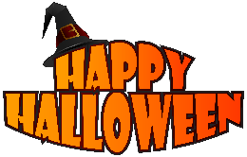

Monday, October 24, 2022

Dear parents & guardians,
As we have had two extra days of holidays this year, we will be celebrating Halloween on two afternoons to ensure our Literacy and Numeracy learning in the mornings.
On Friday, October 28th, we will be having school-based Halloween activities in the afternoon. Students can bring costumes to change into after lunch recess. Please do not send any accessories with the costumes (i.e., masks, make-up, props, or other items that may get lost). Parents can send in treats for the classroom parties.
We are happy to have the return of the Napan Home & School Fall Fair! Please come out on Friday, October 28th from 4-6pm to support their fundraiser.
On Monday, October 31st, we will be having our black & orange day. Please join us for our Family Pumpkin Carving from 1-2pm. This year, we will need pumpkins. Please support this day by bringing in cleaned out pumpkins that are ready to carve.

Thank you,
Ms. Brown

