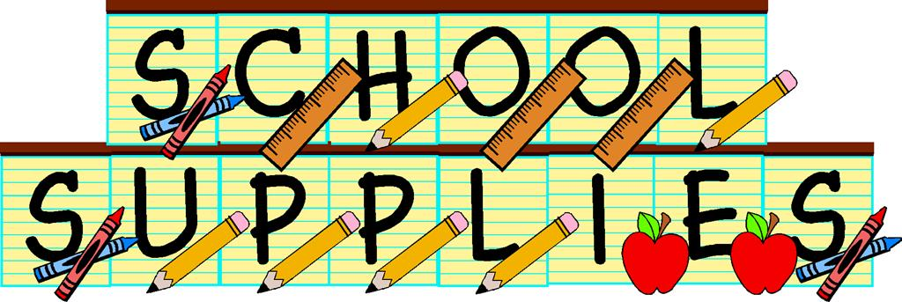

Napan Elementary
Grade Kindergarten
2019-2020

- Indoor/Phys-Ed Sneakers (skateboard and canvas shoes are inappropriate) “Velcro” please
- Full –Size Book Bag
- Lunch Can
- 3 Boxes of Kleenex
- 1 Box of Large Ziplock Baggies
- $35.00 for School Supplies
- 1 change of clothes including shirt, pant, socks, undies in a labeled zip lock bag

